Lab 16

Configuring Domain Controllers

This lab contains the following exercises and activities:

|  |  |
| --- | --- |
| Exercise 16.1 | Promoting Server01 to a Domain Controller |
| Exercise 16.2 | Configuring Universal Group Membership Caching |
| Exercise 16.3 | Moving Operations Masters |
| Exercise 16.4 | Seizing Operations Masters |
| Exercise 16.5 | Creating an RODC |
| Lab Challenge | Cloning a Domain Controller |

BEFORE YOU BEGIN

The lab environment consists of student workstations connected to a local area network, along with a server that functions as the domain controller for a domain called *contoso.com*. The computers required for this lab are listed in Table 16-1.

Table 16-1

Computers Required for Lab 16

|  |  |  |
| --- | --- | --- |
| Computer | Operating System | Computer Name |
| Server (VM 1) | Windows Server 2012 | RWDC01 |
| Server (VM 2) | Windows Server 2012 | Server01 |
| Server (VM 3) | Windows Server 2012 | Server02 |

In addition to the computers, you also require the software listed in Table 16-2 to complete Lab 16.

Table 16-2

Software Required for Lab 16

|  |  |
| --- | --- |
| Software | Location |
| Lab 16 student worksheet | Lab16_worksheet.rtf (provided by instructor) |

Working with Lab Worksheets

Each lab in this manual requires that you answer questions, shoot screen shots, and perform other activities that you will document in a worksheet named for the lab, such as Lab16_worksheet.rtf. You will find these worksheets on the book companion site. It is recommended that you use a USB flash drive to store your worksheets, so you can submit them to your instructor for review. As you perform the exercises in each lab, open the appropriate worksheet file using WordPad, fill in the required information, and save the file to your flash drive.

After completing this lab, you will be able to:

* Configure universal group membership caching (UGMC)
* Transfer and seize operations masters
* Install and configure a Read-Only Domain Controller
* Clone a Domain Controller

Estimated lab time: 95 minutes

|  |  |
| --- | --- |
| Exercise 16.1 | Promoting Server01 to a Domain Controller |
| Overview | During this exercise, you promote Server01 to a domain controller. |
| Completion time | 10 minutes |

**1.** Log in to Server01 as the Contoso\administrator user account. The Server Manager console opens.

**2.** Click the *Yellow triangle with the black exclamation point (!)* and click *Promote this server to a domain controller*.

**3.** When the Deployment Configuration page opens, click Next.

**4.** On the Domain Controller Options page, type **Password01** in the Password and Confirm password text boxes and click Next.

**5.** On the DNS Options page, clickNext.

**6.** On the Additional Options page, click Next.

**7.** On the Paths page, click Next.

**8.** On the Review Options page, click Next.

**9.** After the prerequisites are checked, click Install.

**10.** When the promotion is done, the system restarts automatically.

End of exercise. You can leave the windows open for the next exercise.

|  |  |
| --- | --- |
| Exercise 16.2 | Configuring Universal Group Membership Caching |
| Overview | In this exercise, you enable Universal Group Membership Caching so that your network can become more fault tolerant. |
| Completion time | 5 minutes |

**Mindset Question: For users to be able to log in, they, of course, need a domain controller. What component is needed for users to log in and why?**

**1.** Log in to RWDC01 as the **Contoso\administrator** user account. The Server Manager console opens.

**2.** On Server Manager, click Tools > Active Directory Sites and Services. The Active Directory Sites and Services console opens.

|  |  |
| --- | --- |
| Question 1 | What program is used to enable or disable global catalogs? |

**3.** Expand Sites, and click Default-First-Site-Name.

**4.** Right-click NTDS Site Settings and click Properties. The NTDS Site Settings Properties dialog box opens as shown in Figure 16-1.

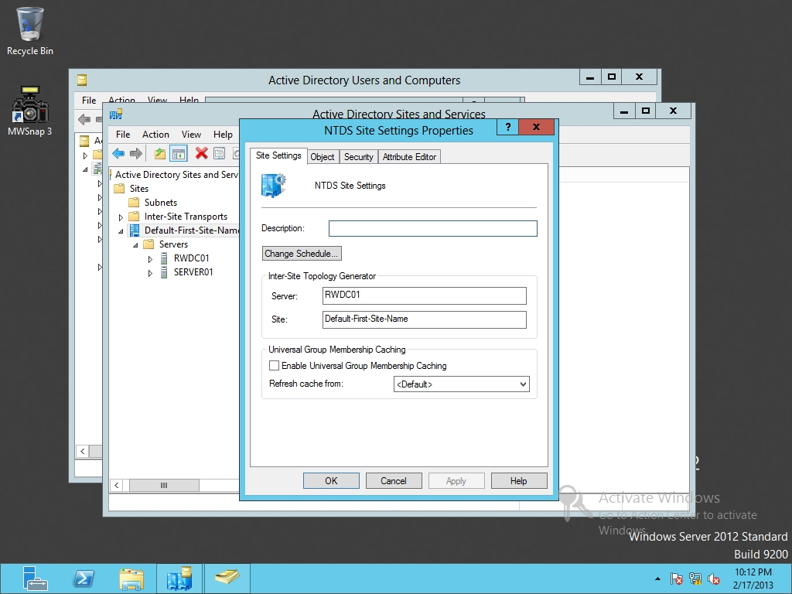

Figure 16-1

Modifying site settings

**5.** Select the *Enable Universal Group Membership Caching* option.

**6.** Click OK to close the NTDS Settings Properties dialog box.

**7.** Close Active Directory Sites and Services.

End of exercise. You can leave the windows open for the next exercise.

|  |  |
| --- | --- |
| Exercise 16.3 | Moving Operations Master |
| Overview | During this exercise, you transfer the Operations Masters to another domain controller. |
| Completion time | 20 minutes |

**Mindset Question: You have multiple sites. During a weekend, you will perform maintenance on the corporate network, which would make those domain controllers (which are also the Operations Masters) unavailable for an extended period of time. What effect will this have on the users on the network and what should you do to minimize down time for the other sites?**

**1.** Log in to Server01 as the **Contoso\administrator** user account. The Server Manager console opens.

**2.** On Server Manager, click Tools > Active Directory Users and Computers. The Active Directory Users and Computers console opens.

**3.** Right-click contoso.com and click Change Domain Controller. Click Server01.contoso.com and click OK.

**4.** Right-click contoso.com and click Operations Masters. The Operations Masters dialog box opens as shown in Figure 16-2.

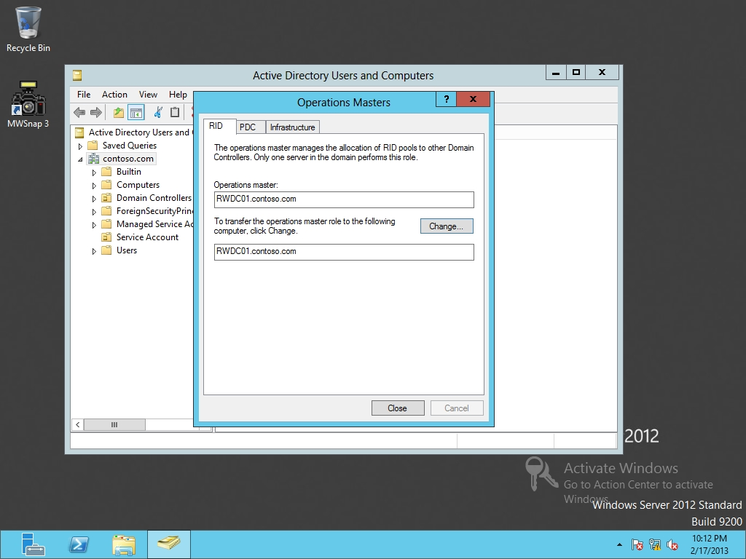

Figure 16-2

Viewing the current domain-level operations masters

**5.** To transfer the RID from RWDC01 to Server01, click Change on the RID tab. When it asks if you are sure, click Yes. When the Operations Master role is transferred, click OK.

**6.** Click the PDC tab. Transfer the PDC Emulator to Server01.

|  |  |
| --- | --- |
| Question 2 | Which Operations Master acts as the master time server and is considered authorative for account passwords? |

**7.** Click the Infrastructure tab. Transfer the Infrastructure to Server01.

**8.** Close the Operations Masters dialog box.

**9.** Close the Active Directory Users and Computers console.

**10.** On Server01, using Server Manager, click Tools > Active Directory Domains and Trusts. The Active Domains and Trusts console opens.

**11.** Right-click Active Directory Domains and Trusts and click Change Active Directory Domain Controller. Click Server01.contoso.com. Click OK.

**12.** Right-click Active Directory Domains and Trusts and select Operations Master. The Operations Master dialog box showing current Domain Naming Operations Master opens.

**13.** Take a screen shot of the Active Directory Domains and Trusts window by pressing Alt+Prt Scr and then paste it into your Lab16_worksheet file in the page provided by pressing Ctrl+V.

**14.** To transfer the Operations Master, click Change. When you're prompted to confirm, click Yes. When the transfer is sucessful, click OK.

**15.** Click Close to close the Operations Master dialog box.

**16.** Close the Active Directory Domains and Trusts console.

**17.** Right-click the start button and select Command Prompt (Admin). The command prompt opens.

**18.** At the command prompt, execute the following command so that you can use the Schema Management console.

Regsvr32 schmmgmt.dll

**19.** When the schmmgmt.dll is registered, click OK.

**20.** At the command prompt, execute the mmc command. The MMC console opens.

**21.** Open the File menu and select Add/Remove Snap-in. The Add or Remove Snap-ins dialog box opens.

**22.** Select Active Directory Schema and click Add. Then click OK to close the Add/Remove Snap-ins dialog box.

**23.** Right-click Active Directory Schema and click Change Active Directory Domain Controller. Click Server01.contoso.com and click OK. When it gives you a warning, click OK.

**24.** Right-click Active Directory Schema and select Operations Master. The Change Schema Master dialog box opens.

**25.** To transfer the Schema Master to Server01, click Change. When it asks if you are sure, click Yes. When the Operations Master is transferred, click OK.

**26.** Click Close to close the Change Schema Master dialog box.

**27.** Close the MMC console. If you are asked to save the console settings, click No. Close the command prompt window.

End of exercise. You can leave the windows open for the next exercise.

|  |  |
| --- | --- |
| Exercise 16.4 | Seizing Operations Masters |
| Overview | In this exercise, instead of transfering the Operations Master, you seize the Operations Masters and move them to another domain controller. |
| Completion time | 10 minutes |

**Mindset Question: The ntdsutil is a powerful tool when managing Active Directory. When should you transfer roles and when should you seize roles?**

**1.** On RWDC01, right-click the Start button and select Command Prompt (Admin). The command prompt opens.

**2.** From the command prompt, execute the ntdsutil command.

**3.** At the ntdsutil prompt, execute the roles command.

**4.** At the fsmo maintenance prompt, execute the connections command.

**5.** At the server connections prompt, execute the following command:

connect to server rwdc01

**6.** At the server connections prompt, execute the quit command.

**7.** To see the available options for fsmo maintenance, press the ? key and press the Enter key.

**8.** To seize the roles, at the fsmo maintenance prompt, type the following commands:

**seize schema master**

**seize naming master**

**seize RID master**

**seize PDC**

**seize infrastructure master**

If an “Are you sure?” dialog box appears, click Yes to continue.

|  |  |
| --- | --- |
| NOTE | When you use the Ntdsutil.exe to seize an operations master role, Ntdsutil.exe will first try to transfer from the current role owner. If the current role owner is not available, the tool seizes the role. Remember, in production, you should only seize a role when the current holder will not be coming back any time soon. |

**9.** At the fsmo maintenance prompt, execute the quit command.

**10.** At the ntdsutil prompt, execute the quitcommand.

**11.** Close the command prompt.

End of exercise. You can leave the windows open for the next exercise.

|  |  |
| --- | --- |
| Exercise 16.5 | Creating an RODC |
| Overview | In this exercise, you create and deploy a read-only domain controller (RODC). |
| Completion time | 20 minutes |

**Mindset Question: So far, we have not had a need for a Read-Only Domain Controller (RODC). When is an RODC necessary?**

**1.** Log in to Server02 as the **Contoso\administrator** user account. The Server Manager console opens.

**2.** On Server Manager, open the Manage menu and click Add Roles and Features.

**3.** When the Add Roles and Features Wizard opens, click Next.

**4.** On the Select installation type page, click Next.

**5.** On the Select destination server page, click Next.

**6.** Click Active Directory Domain Services. When it asks to add features, click Add Features. Then click Next.

**7.** On the Select features page, click Next.

**8.** On the Active Directory Domain Services page, click Next.

**9.** On the Confirm installation selections page, click Install.

**10.** When the installation is complete, click Close.

**11.** On the left pane, click AD DS. On the right-pane click More in the yellow bar.

**12.** When the All Servers Task Details window open, click *Promote this server to a domain controller*. The Active Directory Domain Services Configuration Wizard starts.

**13.** On the Deployment Configuration page, confirm that *Add a domain controller to an existing domain*isalready selected, click Next.

**14.** On the Domain Controllers Options page, selectRead only domain controller (RODC), as shown in Figure 16-3. Select the correct site name (Default-First-Site-Name, in this case). In the Password and Confirm Password text boxes, type **Password01**. Click Next.

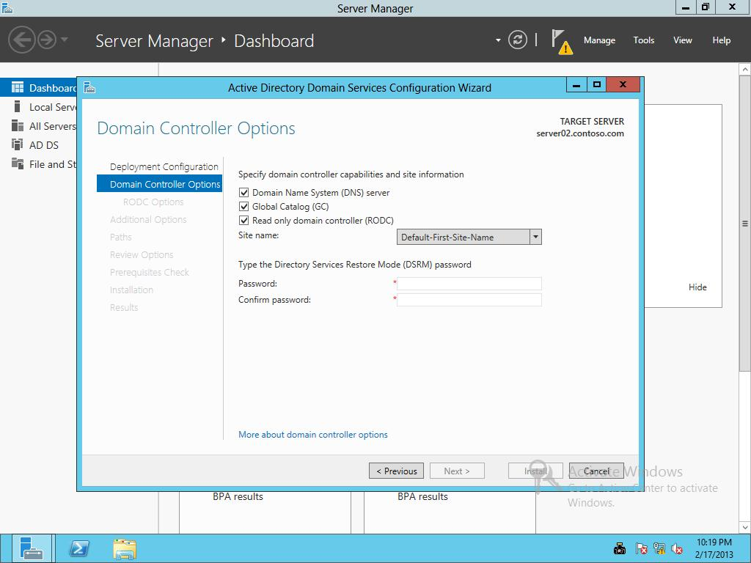

Figure 16-3

Promoting a server to a read-only domain controller

|  |  |
| --- | --- |
| Question 3 | What accounts can replicate passwords to the RODC? |

|  |  |
| --- | --- |
| Question 4 | What accounts are denied from replicating passwords? |

**15.** On the RODC Options page (as shown in Figure 16-4), under Delegated administrator account click Select. In the text box, type **App1Service** and click OK. Click Next.

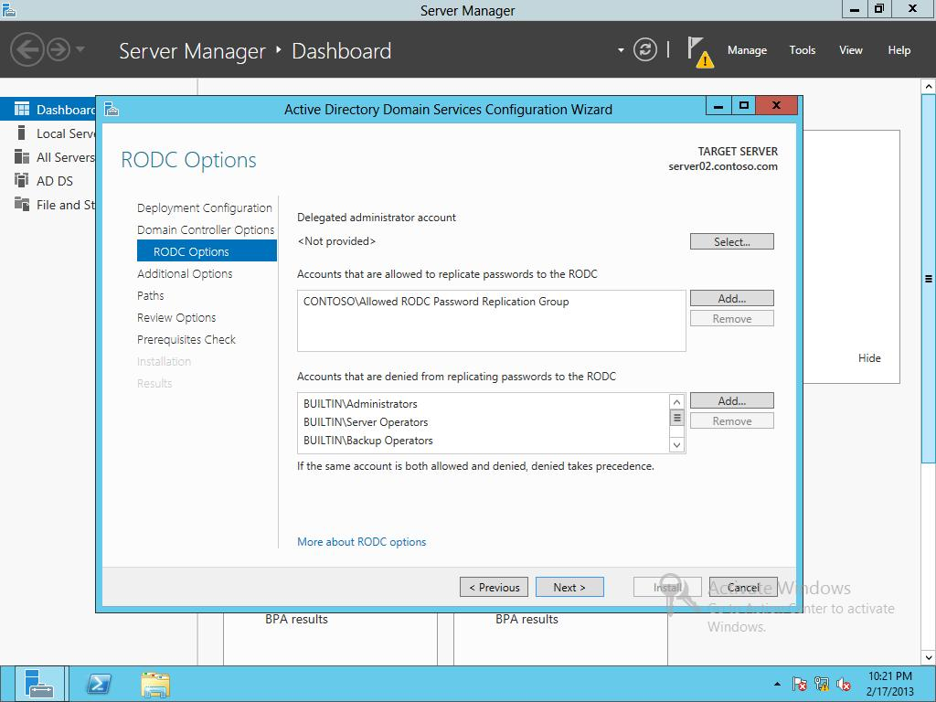

Figure 16-4

Configuring RODC options

**16.** On the Additional Options page, click Next.

**17.** On the Paths page, click Next.

**18.** On the Review Options page, click Next.

**19.** On the Prerequisites Check page, click Install.

**20.** When the installation is complete, Windows automatically restarts the domain controller.

**21.** On RWDC01, using Server Manager, Tools, open Active Diretory Users and Computers.

**22.** Navigate to the Domain Controllers OU. Wait for Server02 to reboot. Then right-click Server02 and click Properties. The Properties dialog box opens.

**23.** Click the Password Replication Policy tab to view the current password replication policies.

**24.** Take a screen shot of the Password Replication Policy tab by pressing Alt+Prt Scr and then paste it into your Lab16_worksheet file in the page provided by pressing Ctrl+V.

**25.** Click OK to close the Server02 Properties dialog box.

Lab REview Questions

|  |  |
| --- | --- |
| **Completion time** | **10 minutes** |

**1.** In Exercise 16.2, what tool was used to enable Universal Group Membership Caching

**2.** In Exercise 16.3, how many PDC emulators are there within a typical organization?

**3.** In Exercise 16.3, when you try to transfer an operations master to another domain controller using an MMC and the source and target domain controllers are the same, what do you have to do?

**4.** In Exercise 16.3, to be able to access the Active Directory Schema console, what must you do first?

**5.** In Exercise 16.3, what did you use to transfer the PDC Emulator role?

**6.** In Exercise 16.4, what did you use to seize the operation masters?

**7.** In Exercise 16.5, where woiuld you go if you need to modify which accounts are replicated to the RODC?

|  |  |
| --- | --- |
| Lab Challenge | Cloning a Domain Controller |
| Overview | To complete this challenge, you must demonstrate how to clone a domain controller by writing the steps to complete the tasks described in the scenerio. Due to time, this is a written-only exercise. |
| Completion time | 20 minutes |

Write out the steps you performed to complete the challenge.

End of lab. You can log off or start a different lab. If you want to restart this lab, you’ll need to click the End Lab button in order for the lab to be reset.